Open Source Islamic Learning Platform
Business Requirements Document (BRD) — Version 4 (Updated)
Roman Urdu Version • Open Marketplace Teaching & Learning Platform
Updated in v4: Secure Onboarding (no plain-text passwords) & Age-Tiered Parent Notifications, Core Platform Forms (field-level spec), Advanced Live Class Features (chat/reactions/raise-hand/waiting-room), Technical & Legal Considerations (RTL, open-source scope, piracy protection, compliance), Security & Compliance Framework, Development & Deployment Workflow. v3: Institute (Madarsa) Persona, Multi-Role Profile Switching. v2: Teacher Onboarding, Course Marketplace, Earning & Payout, Live Class Auto-Attendance, Fee Management, Notifications, Child Safety, Flow Charts.

1. Project Overview
Project Type: Open-source Islamic Education & Learning Platform (Marketplace Model)
Primary Purpose: Quran, Tajweed, Islamic Studies, Arabic aur Higher Islamic Education ko structured, accessible aur quality-controlled online learning system mein provide karna — jahan koi bhi qualified teacher apna course bana sake (free ya paid), live classes le sake aur apne students ko fully manage kar sake, ek hi platform ke andar.
Target Users: Children, Teen Students, Women, Adults, Advanced Islamic Studies Students, Teachers, Course Creators, Administrators, Scholars/Reviewers aur Researchers.
NEW
Core Differentiator: Ye platform ek open teaching marketplace ki tarah kaam karega — jaisa abhi teachers WhatsApp (Student Info + Class), Google Meet/Zoom (Live Class), Notebook/Excel (Attendance, Fees), aur Google Forms (Tests) alag-alag tools mein manage karte hain, wo sab is ek website ke andar integrated honge:
Kaam | Abhi (Manual/Scattered) | Is Platform Par
Student Information | WhatsApp | Built-in Student Directory
Class | Google Meet / Zoom | Native Live Class Module
Attendance | Notebook / Excel | Auto-Attendance (Join/Exit Tracking)
Homework | WhatsApp | Assignment Upload & Review System
Audio Submission | WhatsApp | In-app Audio Recording & Teacher Feedback
Fees | Excel / Notebook | Fee Management + Online Payment
Tests | Google Forms / WhatsApp | Built-in Quiz & Assessment Engine
Progress | Personal Notes | Auto Progress Dashboard

2. Main Website Sections
- Courses: Quran, Tajweed, Hifz, Aqeedah, Fiqh, Hadith, Seerah, Arabic, Tafseer aur Islamic History.
- Kids Academy
- Women Section
- Adults Section
- Aalim/Aalima Higher Studies
- Teacher Training
- Digital Library
- Live Classes
- Tests & Assessments
- Certificates
- Research Section
NEW
- Explore Teachers / Course Creators — public profiles jahan students dekh sakein kaun se teacher kaun se courses offer kar rahe hain (jaisa Udemy instructor profile).
- My Earnings (Teacher-facing) — teacher apni income, payouts track kar sake.

3. Course System
Standard learning flow: Course → Level → Module → Lesson → Activity → Quiz → Assignment → Assessment → Certificate.
Har lesson mein video/audio, notes/PDF, practice activity aur quiz jaise learning resources ho sakte hain.
NEW
Marketplace Model: Har course ek 'Owner Teacher' ke associate hoga. Course ki pricing (Free / One-time Paid / Monthly Subscription), batch size, aur enrollment start/end dates teacher khud set kar sakega, admin approval ke baad.

4. Quran Department
- Noorani Qaida
- Quran Nazra Beginner
- Quran Nazra Intermediate
- Tajweed Foundation
- Tajweed Intermediate
- Advanced Tajweed
- Hifz-ul-Quran
- Quran Revision
- Waqf-o-Ibtida
- Rasm-ul-Khat
- Qira'at Foundation

5. Islamic Studies Department

Aqeedah
- Aqeedah Beginner
- Aqeedah Intermediate
- Aqeedah Advanced
- Usool-e-Aqeedah
- Ilm-ul-Kalam

Fiqh
- Basic Fiqh
- Fiqh-e-Ibadat
- Fiqh Intermediate
- Fiqh Advanced
- Usool-e-Fiqh
- Contemporary Fiqhi Issues

Hadith
- 40 Ahadith
- Selected Ahadith
- Hadith Memorization
- Mustalah-ul-Hadith
- Usool-e-Hadith
- Takhrij Foundation

Seerah & Islamic History
- Seerah Beginner
- Seerah Intermediate
- Seerah Advanced
- Shamail
- Akhlaq-e-Mustafa
- Khulafa-e-Rashideen
- Ahl-e-Bait
- Sahaba
- Sahabiyat
- Islamic Civilization
- Muslim Scholars

6. Arabic Department
- Arabic Level 1: Huroof, vocabulary, basic sentences, greetings aur daily conversation.
- Arabic Level 2: Ism, Fi'l, Harf, Jumla Ismiyyah aur Jumla Fi'liyyah.
- Arabic Level 3 — Sarf: Wazan, Abwab, Tasreef, Masdar, Ism Fa'il, Ism Maf'ool.
- Arabic Level 4 — Nahw: I'rab, Marfoo'aat, Mansubaat, Majrooraat, Mubtada, Khabar, Fa'il, Maf'ool.
- Arabic Level 5 — Balaghat: Ma'ani, Bayan, Badi'.
- Arabic Level 6 — Advanced Reading: Quranic Arabic, Hadith Arabic, Fiqhi Arabic, Classical Arabic aur Arabic Literature.

7. Quran Translation & Tafseer
- Quran Samajhna — Basic Translation
- Selected Surahs
- Usool-e-Tafseer
- Uloom-ul-Quran
- Classical Tafseer Studies
- Tafseer Methodology
- Comparative Tafseer

8. Kids Academy
- Age 5–7: Qaida, short Surahs, Kalimas, Duas, Islamic Stories, Adab.
- Age 8–10: Nazra, Tajweed, Namaz, Aqeedah Basics, Seerah, Hadith.
- Age 11–13: Fiqh, Aqeedah, Arabic, Hadith, Seerah, Islamic History.
- Age 14–17: Advanced Islamic Studies, Arabic, Fiqh, Hadith, Tafseer, Aqeedah aur Contemporary Questions.

9. Women's Section
- Fiqh-e-Niswan
- Taharat
- Haiz
- Nifas
- Istihaza
- Salah
- Roza
- Nikah
- Family-related Islamic Education
- Seerah of Sahabiyat
- Islamic Parenting
Sensitive subjects ke courses mein qualified scholars aur carefully reviewed material ka workflow hona chahiye.

10. Aalim/Aalima Program
Foundation → Arabic Foundation → Sarf & Nahw → Fiqh & Aqeedah → Hadith → Tafseer → Usool → Advanced Islamic Studies → Aalamiyat → Takhassus.
Formal Aalim/Aalima qualification ka claim sirf relevant accreditation/authorization ki surat mein kiya jaye.

11. Teacher Portal
- Course create/edit
- Lessons upload
- PDF/video/audio attach
- Quiz create
- Assignments check
- Marks enter
- Student progress
- Attendance
- Feedback
- Live class scheduling
- Student Q&A
NEW
- Teacher Verification Status & Credential Upload
- Student Directory (naam, contact, enrollment history — WhatsApp ka replacement)
- Fee Management per Student (kis ne pay kiya, kis ka due hai)
- Earnings & Payout Dashboard
- Notification Center (class reminders, homework due, announcements bhejna)
- Batch/Group Management

12. Student Dashboard
- My Courses
- Continue Learning
- Completed Lessons
- Progress %
- Quiz Results
- Assignments
- Certificates
- Attendance
- Teacher Feedback
- Bookmarks
- Personal Notes
NEW
- My Payments / Invoices
- Notification Preferences
- Parent/Guardian Linked View (agar minor student hai)

13. Assessment System
- Lesson Quiz: 5–10 questions
- Module Test: 20–30 questions
- Mid-Term
- Final Examination
- Written/Assignment assessment
- Practical assessment
Tajweed/Nazra ke liye audio submission → teacher review → mistakes/feedback → re-record workflow hona chahiye.

14. Audio Recording & Tajweed Practice
Student recitation record karke submit kare; teacher audio sun kar Makharij, Madd, Ghunnah, Qalqalah waghera par targeted feedback de aur reattempt allow kare.

15. Live Classes
- Teacher creates class
- Date/time
- Course & batch
- Student list
- Meeting link
- Attendance
- Class notes/recording where permitted
UPDATED — DETAILED DESIGN
Ye platform ka ek core requirement hai: daily live class jo assigned course/batch ke duration tak chalegi, aur har student ka join/exit automatically track hoga — bina kisi manual register ke.

15.1 Auto-Attendance — Kaise Kaam Karega
- Teacher class schedule karta hai: course, batch, date, start time, duration.
- Jab student meeting join kare, system real-time 'joinTime' capture karta hai (video SDK ke join event se).
- Agar student beech mein exit kare (network issue ya jaan-bujh kar), system 'leaveTime' record karta hai.
- Agar student dobara join kare, ek naya session start hota hai (naya joinTime).
- Class khatam hone par, system saare sessions ka total duration sum karta hai.
- Threshold ke hisaab se status auto-assign hota hai: Present (>=70%), Partial (40-70%), Absent (<40%) — threshold admin configurable rakhega.
- Teacher/Admin dashboard par har student ka pura join/exit history aur final % dikhega.

15.2 Database Structure (Reference)
liveClasses { classId, courseId, batchId, teacherId, scheduledStart, scheduledEnd, actualDuration }
attendance { classId, studentId, sessions: [{joinTime, leaveTime, durationMinutes}, ...], totalDuration, attendancePercentage, status }
Complete visual flow: dekhiye Appendix — Flow Chart 3 (Live Class Auto-Attendance).

15.3 In-Class Interaction Features
NEW — v4
- Mic Mute/Unmute — har participant khud control kare; teacher (moderator) 'mute all' aur kisi specific student ko mute kar sake
- Camera On/Off — student khud control kare; teacher zaroorat par force-off kar sake (privacy/bandwidth ke liye)
- Raise Hand — queue/list ke roop mein teacher ko dikhe, order ke hisaab se unmute karke bulaya ja sake
- Live Chat — sabke liye ya teacher ko private message; basic profanity/moderation filter zaroori (bachchon ki classes ke liye)
- Emoji Reactions — limited set (👍❤️🎉), floating temporarily — engagement ke liye, distraction na banein
- Waiting Room / Lobby — student join request kare, teacher approve kare tabhi andar aaye (child-safety ke liye important)
- Teacher Spotlight/Pin — kisi bhi student ka video sabko dikhaya ja sake (recitation check karte waqt useful)
Ye saare features standard video SDK (Jitsi/100ms/Agora) mein already built-in milte hain — alag se banane ki zaroorat nahi, bas integrate karna hai.

16. Islamic Digital Library
- Quran
- Tafseer
- Hadith
- Fiqh
- Aqeedah
- Arabic
- Seerah
- Islamic History
- Urdu Books
- Research Papers
Har resource ke saath Author, Language, Subject, Edition, Source aur Copyright/License information maintain ki jaye. Har kitab/PDF automatically open-source nahi hoti.

17. Search System
Search results mein Course, Lesson, Article, Book, Video aur Quiz aa sakte hain. Filters: Subject, Level, Language, Format aur Author/Scholar.
NEW
- Filter: Free vs Paid, Teacher Name, Rating (agar review system add kiya jaye).

18. Multi-Language
Initial languages: Urdu + Roman Urdu + English. Future expansion: Hindi, Arabic, Bengali, Gujarati, Malayalam, Tamil etc.

19. Certificate System
- Student Name
- Course
- Duration
- Completion Date
- Grade
- Certificate ID
- Verification QR
- Issuing Organization
Course Completion Certificate ko formal Aalim/Aalima degree se clearly separate rakha jaye.

20. Admin Dashboard
- Users: Students, Teachers, Authors, Moderators
- Courses: Draft, Review, Published, Archived
- Analytics: Enrollments, Active Students, Completion Rate, Quiz Performance, Engagement
NEW
- Teacher Verification Queue
- Platform Revenue & Payout Overview
- Reported Content/Q&A Moderation Queue
- Fee & Transaction Reports

21. Content Review System
Recommended workflow: Teacher/Author → Content Submitted → Academic Reviewer → Scholar Review → Admin Approval → Published.
Har religious lesson ke saath Source/Reference, Reviewer, Review Date aur Version maintain kiya ja sakta hai.
Complete visual flow: dekhiye Appendix — Flow Chart 2 (Teacher/Course Review Workflow).

22. Q&A / Discussion
- Lesson-level Ask a Question
- Teacher replies
- Moderation
- Advanced religious questions ke liye Scholar Review Required workflow
NEW
- Report Button — student/teacher inappropriate ya galat content report kar sakein, jo moderation queue mein jaaye.

23. Research Section
- Research Methodology
- Source Verification
- Bibliography
- Hadith Referencing
- Arabic Text Analysis
- Academic Writing
- Islamic Research Projects

24. Ideal Learning Flow
Create Account → Choose Goal → Level Assessment → Recommended Course/Level → Enroll → Learn → Practice → Quiz → Teacher Feedback → Final Assessment → Certificate → Next Level.
Complete visual flow: dekhiye Appendix — Flow Chart 1 (Student Learning Journey).

25. Open-Source Technology Strategy
Option A: Existing open-source LMS ko customize karna, jaise Moodle ya Open edX.
Option B: Apna LMS from scratch develop karna.
Final technical decision ke baad detailed technical architecture, database schema, APIs, pages, roles/permissions, hosting, security aur mobile strategy finalize ki jaye.

26. Recommended User Roles
- Super Admin
- Academic Admin
- Course Manager
- Scholar Reviewer
- Independent Teacher (individual, platform ke sath directly registered)
- Institute Admin (NEW — madarsa/institute ka owner/manager)
- Institute-affiliated Teacher (NEW — institute ke under kaam karne wala teacher)
- Teaching Assistant
- Content Author
- Moderator
- Student
- Parent/Guardian

27. Institute (Madarsa) Persona
NEW SECTION — Critical Gap
Original BRD mein sirf Individual Teacher aur Student socha gaya tha. Lekin bahut saare Islamic institutes/madaris hain jahan ek se zyada teachers milkar padhate hain, aur institute apni ek collective identity ke saath platform par aana chahega — na ki har teacher alag-alag independent profile ke saath. Ye persona formally add kiya ja raha hai.

27.1 Institute vs Individual Teacher — Key Differences
Pehlu | Individual Teacher | Institute (Madarsa)
Kaun manage karta hai | Khud apne courses | Multiple teachers (staff) ko manage karta hai
Students | Apne khud ke enrolled students | Sabhi teachers ke students, institute ke naam se
Earnings | Apni khud ki earning seedhi | Institute-level revenue, phir teachers ko internally distribute
Certificate | Teacher ka naam / Platform naam | Institute/Madarsa ka naam aur logo
Verification | Individual credential check | Institute recognition document + har teacher ki alag verification
Branding | Minimal, profile-level | Apna logo, naam, dedicated public page

27.2 Institute Admin — Core Features
- Institute registration & verification (recognition/registration document upload, alag verification workflow individual teacher se)
- Teacher staff management — teacher ko institute mein add/remove karna, unko roles dena (jaise 'Senior Teacher', 'Assistant Teacher')
- Institute structure: Institute → Departments (Quran/Islamic Studies/Arabic) → Teachers → Batches → Students
- Institute-wide analytics — sabhi teachers ka combined performance, attendance, revenue ek hi dashboard mein
- Institute-level fee collection & consolidated financial reports (sabhi batches ki fees ek jagah)
- Institute branding — apna logo aur naam course pages aur certificates par dikhna
- Internal content review — institute apne teachers ke courses ko pehle khud review kar sake, phir platform-level Scholar Review ke liye jaye

27.3 Revenue Split — Institute Model
Individual teacher ke liye split sirf 2-level hai (Platform ↔ Teacher). Institute ke liye ye 3-level hoga:
Student Payment → Platform Fee Deducted (%) → Institute Share → Institute apne andar Teacher ko uska hissa deta hai (ye split institute khud apne policy ke hisaab se set kar sakta hai, platform sirf Institute tak revenue pahunchayega).

27.4 Database Reference
institutes { instituteId, name, logoUrl, verificationStatus, ownerId }
instituteStaff { instituteId, teacherId, roleInInstitute, addedBy }
courses { ..., ownerType: 'individual_teacher' | 'institute', instituteId (nullable) }

28. Multi-Role Profile Switching
NEW SECTION — Critical Gap
Ek hi insaan ek saath Student ho sakta hai (khud kuch seekh raha ho), Teacher bhi (kisi ko padha raha ho), aur Institute Admin bhi (apna madarsa chala raha ho). Login/signup identity ek hi rahegi, lekin har role ka apna alag dashboard aur data hoga.

28.1 Account vs Profile — Design
- Account = login identity (email/phone/password ya OTP) — ye sirf ek baar banta hai
- Profile = ek role (Student / Teacher / Institute Admin) us account ke andar — ek account ke multiple profiles ho sakte hain
- Login ke baad agar user ke paas 1 se zyada profile hai, top-right corner mein ek profile-switcher dikhega (jaisa Google account ya Slack workspace switch karna)
- Profile switch karne par sirf 'active context' change hota hai — data, dashboard, permissions sab us profile ke hisaab se load hote hain
- Naya profile add karna kabhi bhi possible ho (jaise ek Student baad mein Teacher bhi banna chahe, ya kisi institute join kare)

28.2 Database Reference
users { userId, email, phone, passwordHash }
profiles { profileId, userId, role: 'student' | 'teacher' | 'institute_admin', linkedInstituteId (nullable), status }
Security note: har API request pe backend session ke 'active profile' se role-check hoga — ek profile ka token doosre profile ka data access nahi kar sakta, chahe dono ek hi account ke under kyun na hon.

29. Teacher Onboarding & Verification
NEW SECTION
Chunki platform open hai (koi bhi apna course bana sake), teacher verification zaroori hai taaki students trust kar sakein aur religious content ki authenticity bani rahe.
- Teacher signup ke baad profile + credentials submit (ijazah/qualification proof optional lekin recommended, especially Quran/Fiqh/Aqeedah teachers ke liye)
- Admin/Academic Admin verification ke baad hi teacher course publish kar sakega ya live class le sakega
- 'Verified Teacher' badge system — students trust ke liye
- Naye teacher ke liye probation period: shuru mein sirf 1 course publish allow, feedback ke baad limit badhe

30. Course Marketplace Model
NEW SECTION
Platform essentially ek Islamic education marketplace ki tarah kaam karega — jaisa Udemy — jahan verified teachers apna course khud create, price aur manage karte hain.
- Har teacher ki apni 'mini academy' profile hogi (courses list, bio, rating, student count)
- Course Free ya Paid rakhne ka option teacher ke paas (one-time price ya monthly subscription)
- Admin platform-wide quality control rakhega (Section 21 ka review workflow), lekin course ka content ownership teacher ka rahega
- Multi-tenancy design: database mein har course/batch/student data teacher-scoped (ya institute-scoped) hoga, taaki ek teacher/institute doosre ka data na dekh sake
- Course ka owner ya to ek Independent Teacher hoga ya ek Institute (dekhiye Section 27) — dono ke liye same marketplace mechanics apply hongi, bas institute ke courses par institute ka branding aur multi-teacher management extra layer ki tarah upar hoga

31. Teacher Earning & Payout System
NEW SECTION
- Revenue-sharing model define karna: platform ka cut % (jaise industry standard 15-30%) aur teacher ka share
- Teacher apna bank account/UPI add kare payout ke liye
- Earnings dashboard — kitna kamaya (course-wise), kab settle hoga
- Automated split payment (Razorpay Route / RazorpayX jaisa system) — ek payment automatically platform aur teacher ke beech split ho jaaye
- Payout cycle define karna (weekly/monthly), minimum payout threshold
Complete visual flow: dekhiye Appendix — Flow Chart 4 (Payment & Teacher Earning Flow).

32. Fee Management System
NEW SECTION — replaces Excel/Notebook workflow
- Teacher apne course/batch ki fee set kare (one-time / monthly / per-batch)
- Auto invoice/receipt generation har payment ke baad
- Due/Pending fee tracking — kis student ka kitna due hai, automatic reminder
- Fee history — student aur teacher dono ke liye transparent record

33. Notification System
NEW SECTION — replaces WhatsApp workflow
- In-app + Email + SMS notifications (WhatsApp ka replacement)
- Class reminder (15 min pehle automatic)
- Homework due reminder
- New feedback/grade notification
- Fee due reminder
- Teacher broadcast announcement (batch-wise ya course-wise)

34. Homework / Assignment Submission Flow
NEW SECTION — replaces WhatsApp workflow
- Student file/text/PDF upload kare assignment ke liye
- Teacher review kare, marks/feedback de
- Agar resubmission chahiye toh 'Resubmit' status set ho (jaisa Tajweed audio workflow mein hai)
- Assignment history student dashboard mein save rahe

35. Child Safety & Data Privacy
NEW SECTION — Critical
- Under-13 (ya region ke hisaab se minor) students ke liye Parent/Guardian consent zaroori
- Parent Dashboard (Phase 2 mein already listed) — bachche ki progress, attendance, fees dekh sakein
- Live class recording ke liye consent lena
- Teacher-Student direct contact (personal number/email) platform se bahar share na ho — sab communication in-app rahe
- Data encryption (in-transit aur at-rest), regular security audits
- Privacy Policy aur Terms of Service page — legally zaroori

36. Reporting & Moderation
NEW SECTION
- Q&A, comments, aur course content ke liye report button
- Moderation queue admin ke paas
- Repeated violations par teacher/student account suspend karne ka process

37. Core MVP — Phase 1
- User registration/login (Student, Teacher, Admin roles)
- Teacher onboarding & basic verification
- Student & Teacher dashboards
- Course/lesson management (Free courses)
- Video/audio/PDF lessons
- Quizzes
- Progress tracking
- Teacher feedback
- Basic certificates
- Search
- Admin panel
- Content review workflow

38. Phase 2 — Monetization & Live Learning
- Paid courses + Razorpay/UPI payment integration
- Teacher earning & payout system
- Fee management
- Live classes with auto-attendance
- Student audio recording
- Tajweed practical assessment
- Assignments (full submission flow)
- Discussion/Q&A
- Notification system
- Advanced analytics
- Parent dashboard
- Mobile app/PWA
- Digital library

39. Phase 3 — Full Islamic Learning Ecosystem
- Aalim/Aalima pathway
- Takhassus pathways
- Research portal
- Teacher training
- Multi-language expansion
- Scholar review network
- Open-source contributor community
- Public API/integration ecosystem
- Rating & review system for teachers/courses

40. Key Quality Principles
- Authentic and referenced Islamic content
- Clear distinction between source, interpretation and teacher explanation
- Qualified scholarly review for religious content
- Age-appropriate curriculum
- Accessible learning design
- Transparent content licensing
- Privacy and child-safety controls
- Version control for updated lessons
- Regular academic review
- Transparent teacher revenue-sharing (NEW)
- Secure payment handling (NEW)

41. Secure Onboarding & Notification Flow
NEW SECTION — v4
Jab teacher/institute kisi student ko batch mein add kare, account creation aur notification dono secure aur age-aware tarike se hone chahiye.

41.1 Secure Account Setup (No Plain-Text Passwords)
- Password kabhi bhi Email/WhatsApp mein plain-text mein nahi bheja jayega — ye ek genuine security risk hai (messages hamesha ke liye stored reh jate hain)
- Teacher student ko add kare → system account bana de, par password khud set NA kare
- Student ko ek secure, time-limited 'Set Your Password' link jaaye (Email + WhatsApp dono par)
- Student link kholke khud apna password banaye — 'Forgot Password' bhi isi tarah kaam karega

41.2 Age-Based Parent/Guardian Notification Tiers
Age Group | Parent/Guardian Field | Notifications Parent ko
Under 14 | Mandatory | Sab kuch — routine bhi (class reminder, homework) aur critical bhi (attendance, fees)
14–17 | Recommended (optional) | Sirf Critical — attendance miss (2-3 consecutive), fee due, safety-related alerts
18+ | Not required | Koi parent notification nahi — student fully independent

41.3 Notification Channel Strategy — Cost-Conscious
Channel | Cost | Kab use karo
Email | Free | Primary channel — welcome, course details, receipts, sab kuch
In-App Notification | Free | Notification bell — app khulte hi dikhe
Push Notification (PWA) | Free | Mobile-jaisa turant alert, bina WhatsApp cost ke
WhatsApp (Utility category) | ~₹0.115-0.20/msg + BSP platform fee | Sirf critical/time-sensitive — live class 15-min reminder, fee due
SMS | ~₹0.15-0.25/msg | Sirf OTP/login verification ke liye
Recommended phased rollout: Phase 1 mein sirf Email + In-App (zero cost). Phase 2 mein Push Notification (PWA, zero cost) add karo. Phase 3 mein WhatsApp Utility messages add karo jab budget aur user-base dono badh jayein.
Complete visual flow: dekhiye Appendix — Flow Chart 5 (Secure Onboarding & Age-Tiered Notifications).

42. Core Platform Forms — Field Specifications
NEW SECTION — v4
Flow: Teacher/Institute → Course banata hai → Course ke andar Batch(es) banata hai → Batch mein Students add karta hai → Batch ke liye Live Class schedule karta hai.

42.1 Course Create Form
Field | Type
Course Title | Text
Description | Text area
Department/Category | Dropdown
Level | Dropdown (Beginner/Intermediate/Advanced)
Thumbnail Image | File upload
Free or Paid | Toggle
Price (agar Paid) | Number
Language | Dropdown
Course Duration | Number (weeks/months)

42.2 Batch Create Form
Field | Type
Batch Name | Text
Linked Course | Dropdown
Start Date | Date
Schedule Days | Multi-select
Class Time | Time
Max Students | Number
Assigned Teacher | Dropdown (institute ke liye)

42.3 Student Add/Invite Form
Field | Type | Required?
Student Name | Text | Required
Date of Birth | Date | Required (age-tier logic ke liye)
Email | Text | Required
Phone (WhatsApp) | Text | Required
Batch | Dropdown | Required
Parent/Guardian Name | Text | Required agar age < 14
Parent/Guardian Email | Text | Required agar age < 14
Parent/Guardian Phone | Text | Required agar age < 14
Relationship | Dropdown | Required agar age < 14
Bulk Upload (CSV) | File upload | Optional — institute ke liye

42.4 Live Class Schedule Form
Field | Type
Batch | Dropdown
Date | Date
Start Time | Time
Duration | Number (minutes)
Recurring? | Toggle (Daily/Weekly/One-time)
Recording Allowed? | Toggle
Topic/Lesson Title | Text

43. Additional Recommended Features
NEW SECTION — v4
- Recording & Playback — live class record ho (teacher-permission se), jo student miss kare wo baad mein dekh sake
- Low-Bandwidth / Audio-Only Mode — network issues mein automatically audio-only switch ho, class continue rahe
- Multi-Device Login Restriction — ek account ek time par sirf 1-2 devices tak active, login-sharing rokne ke liye
- Calendar Integration — 'Add to Calendar' se student apna Google Calendar mein class add kar sake
- Class Recording Consent — recording se pehle students/parents ko inform aur consent lena (child-safety)
- Missed Class Auto-Alert — student consecutive 2-3 classes miss kare toh teacher/parent ko automatic alert

44. Technical & Legal Considerations
NEW SECTION — v4

44.1 RTL & Arabic/Urdu Text Support
Quran/Arabic/Urdu content Right-to-Left (RTL) hota hai, jabki English/Roman Urdu Left-to-Right (LTR). Ye architecture-level decision hai jo shuru se hi plan karna hoga — baad mein retrofit karna bahut mushkil hota hai. Requirements: Arabic text ke liye RTL-compatible fonts (Amiri, Noto Naskh Arabic), Tashkeel/Harakat (zabar-zair-pesh) correctly display hon, aur agar Urdu Nastaliq interface chahiye toh poora layout mirror ho sake.

44.2 Platform Naming & Open-Source Scope
'Open Source' naam ka matlab clearly define kiya gaya hai: platform ka codebase open-source NAHI rahega (security aur business dono reasons se — public code mein vulnerabilities dhoondhna aasan ho jata hai, aur competitors copy kar sakte hain). 'Open' positioning sirf iska matlab hai ki koi bhi verified teacher/institute apna course bana sake (open marketplace/enrollment model), na ki source code open ho. Future mein agar community-contribution chahiye, sirf curriculum content (non-proprietary study material) open rakha ja sakta hai, core platform code (auth, payments, admin) closed rahega.

44.3 Paid Content Piracy Protection
Free courses ke liye YouTube Unlisted theek hai (sasta, chori hone par bhi financial loss nahi). Paid courses ke liye video apne platform ke andar host karna better hai — Cloudflare Stream ya Bunny.net jaisi service se, jo token-based/DRM access deti hai (link forward karne se bhi kaam nahi karega bina valid login/purchase ke).

44.4 Legal & Compliance
- Terms of Service + Refund Policy — paid course refund rules clearly likhe hon
- GST Invoicing — applicable threshold ke upar, har payment ka proper invoice
- RBI Payment Aggregator Guidelines — teacher payout involve karne se ye apply ho sakti hain; Razorpay Route jaisi service se largely handled ho jata hai
- Teacher-Platform Agreement — revenue split, content ownership, aur teacher platform chhode toh students/courses ka kya hoga, ye likhit hona chahiye
- India's DPDP Act (Digital Personal Data Protection Act) — user data collect karne se pehle consent, data minimization, aur breach hone par notify karna legally zaroori hai

44.5 MVP Scope — Realistic Sequencing
Scope creep se bachne ke liye, ek genuinely minimal v1 finalize karna zaroori hai: Auth (Student+Teacher, profile-switching database-ready) → Free courses only → Video (YouTube embed) + PDF → Basic quiz → Live class (bina advanced features, sirf join/leave) → Manual attendance pehle, phir automated. Baaki sab (Institute, payments, WhatsApp, advanced live features) Phase 2/3 mein — jaisa Section 37-39 mein already planned hai.

44.6 Live Class Scalability
Self-hosted Jitsi ek single server par kam concurrent users (50-100) ke liye theek hai. Jaise-jaise users badhenge, managed service (100ms/Agora) par switch karne ka plan rakhna chahiye — ye infra cost badhayega lekin reliability bhi badhayega.

45. Security & Compliance Framework
NEW SECTION — v4 — Critical
Security ek one-time kaam nahi, ek continuous process hai. 4 layers mein design kiya gaya hai:

45.1 Layer A — Design Time
- Role-Based Access Control (RBAC) hamesha backend pe enforce ho, frontend check sirf UI ke liye
- Least Privilege Principle — har role ko sirf utna hi access jitna zaroori hai
- Data encryption — passwords bcrypt se hashed, saara data-in-transit HTTPS/TLS se encrypted

45.2 Layer B — Development Time
- Khud crypto/security logic kabhi mat likho — established libraries use karo (bcrypt, jsonwebtoken, Passport.js)
- Input validation & sanitization har form field pe (SQL injection/XSS se bachne ke liye)
- Secrets kabhi code mein hardcode mat karo — .env files use karo, .gitignore mein rakho
- Dependency scanning — npm audit regularly chalao
- Code review — har naya feature merge se pehle check karo

45.3 Layer C — Deployment Time
- HTTPS everywhere, kabhi HTTP pe live mat jao
- Security headers (Content-Security-Policy, X-Frame-Options, etc.)
- Rate limiting login/signup pe brute-force rokne ke liye
- Environment separation — Development/Staging/Production alag rakho
- Payment security — card details kabhi khud store mat karo, Razorpay jaisi PCI-DSS compliant service par chhodo

45.4 Layer D — Ongoing Operations
- Regular automated backups (daily), aur restore bhi periodically test karo
- Admin/Institute Admin accounts par 2FA (Two-Factor Authentication) mandatory
- Monitoring & Alerts — unusual activity (failed logins, spike in API calls) par notification
- Server OS, libraries, dependencies regularly update karo
- Incident Response Plan pehle se socha ho (breach hone par users ko inform karna, passwords reset karwana)
- DPDP Act Compliance (Section 44.4 dekhen)
- Platform scale karne par professional Security Audit/Penetration Testing karwana

46. Development & Deployment Workflow
NEW SECTION — v4
- Code Storage: GitHub (private repository) — version history ke saath, sabse standard choice
- Local Development: roz ka kaam apne computer pe (localhost), database ka ek free/test project alag se
- Staging Environment: Vercel (frontend) aur Railway/Render (backend) — GitHub se connect karne par automatically preview link ban jata hai har naye push par
- CI/CD (Continuous Integration/Deployment): GitHub push → automatic staging build → test karo → 'main' branch mein merge → production automatically live
- Branch Strategy: 'main' branch sirf live/production ke liye; 'dev'/'staging' branch par naya kaam/testing; feature poora test hone ke baad hi main mein merge
- Environment Separation: Development, Staging, aur Production ke liye alag database projects (Supabase/MongoDB Atlas), kabhi mix na karein
- Domain Connection: final testing ke baad, khareeda hua custom domain production URL se connect karo
Ye poora setup shuru mein bilkul free hai (GitHub free, Vercel free, Railway/Render free tier) — users badhne par hi paid tier lena padega.

Appendix — Flow Charts
In flow charts mein platform ke sabse important workflows cover kiye gaye hain, jaisa BRD mein describe kiya gaya hai.

Flow Chart 1: Student Learning Journey
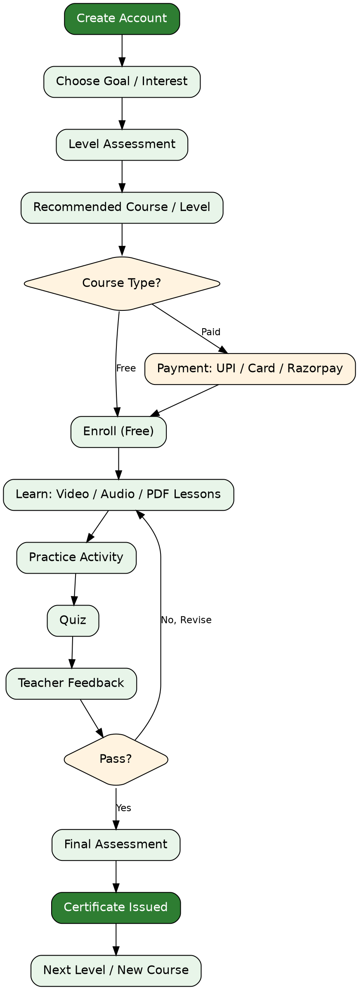

Flow Chart 2: Teacher & Course Review Workflow
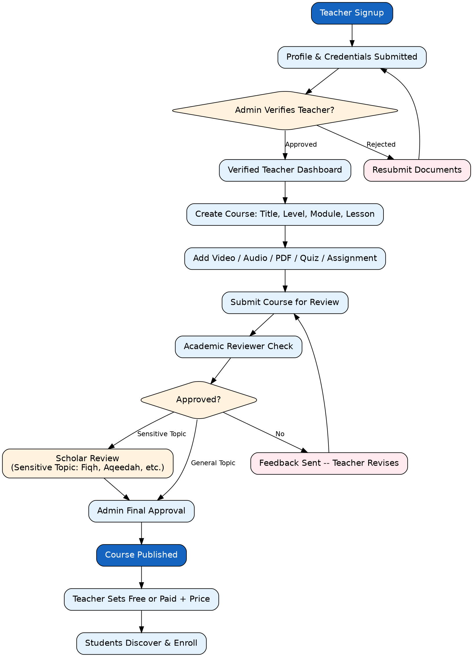

Flow Chart 3: Live Class — Auto-Attendance
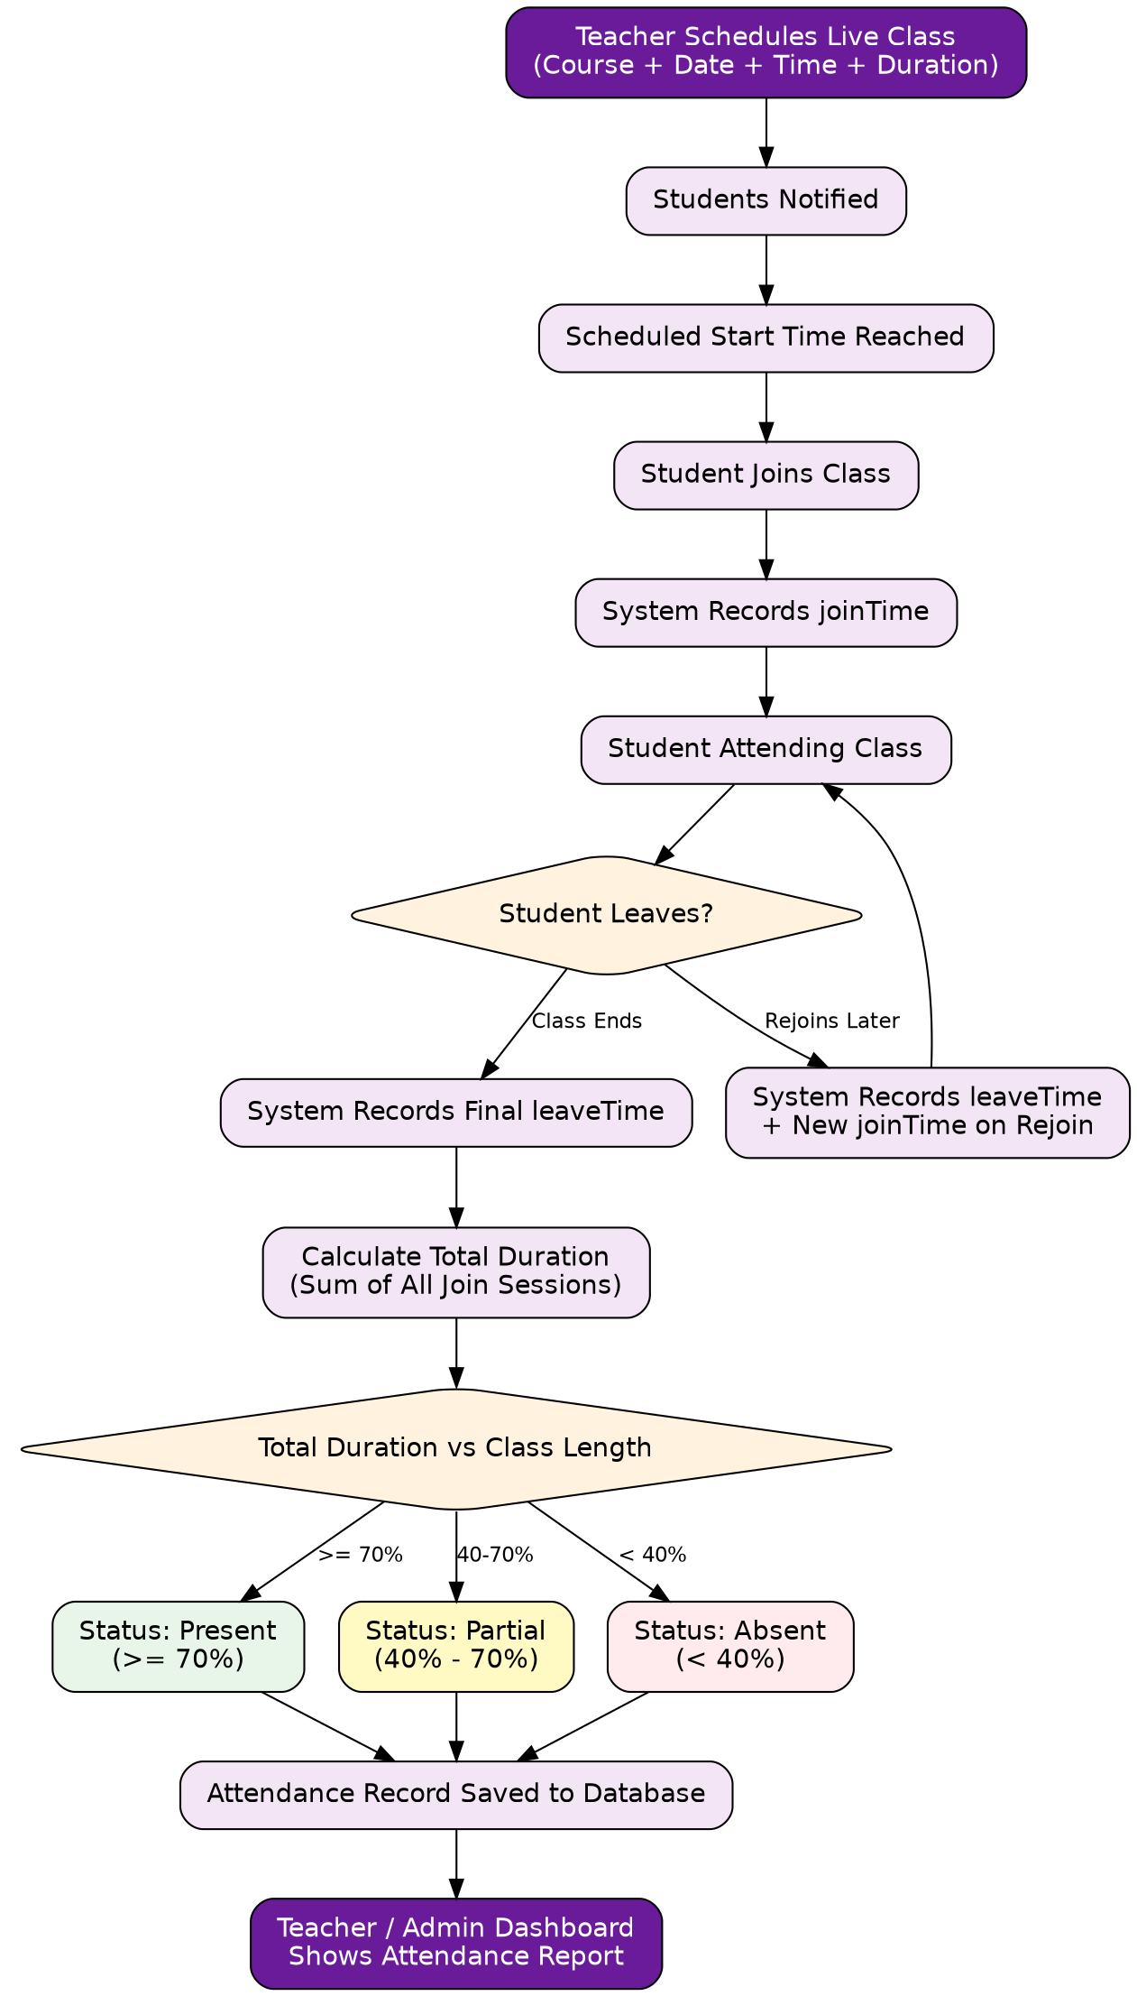

Flow Chart 4: Payment & Teacher Earning Flow
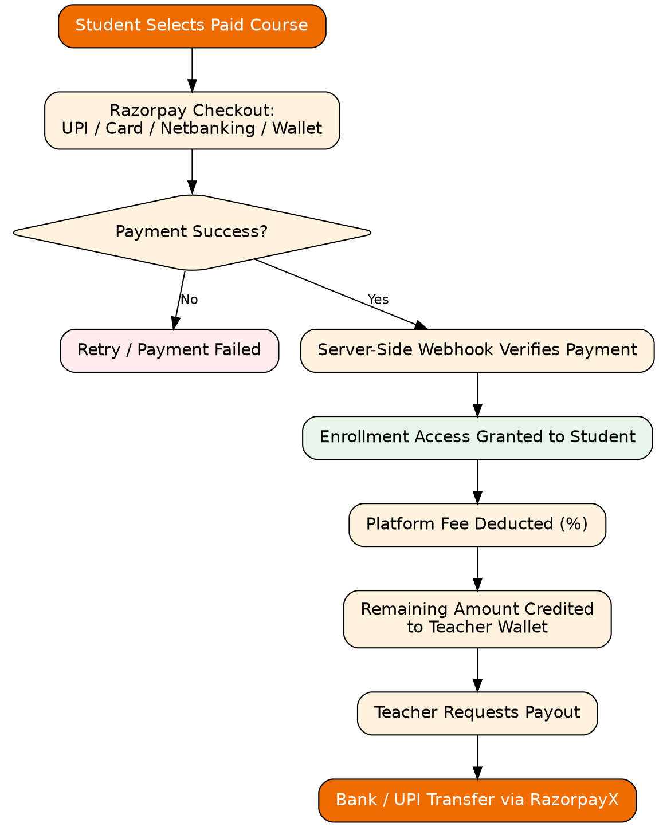

Flow Chart 5: Secure Onboarding & Age-Tiered Parent Notifications
